Patching Server using Satellite Server

Step 1 Verify repositories are synchronized



Step 2 Publish Content View



Step 3. Promote Content View



Step 4. Verify Registration to Foreman and Katello.

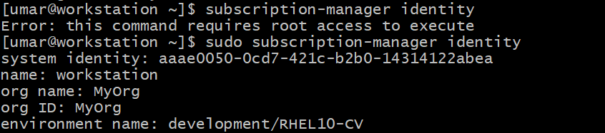

Step 5. Check Installed Packages

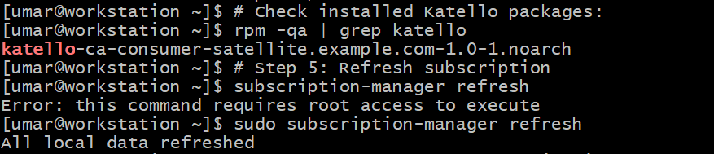

Step 6. Check Enabled repositories

Step 7. Clear Metadata



Step 8. Check Available Updates & Apply Patches

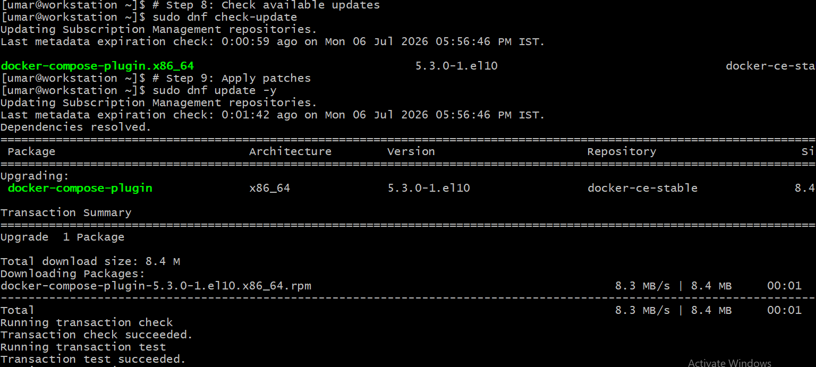

Step 9. Validate Patching

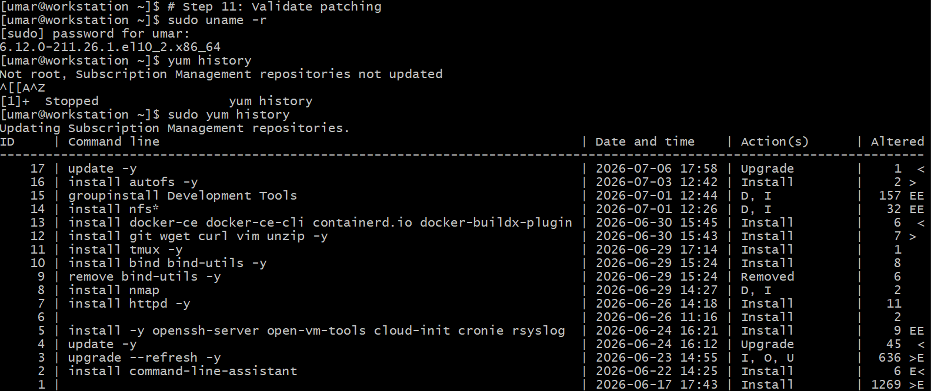

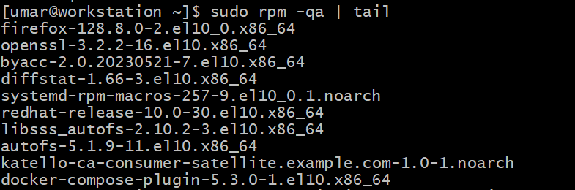

Step 10. Validate in Foreman UI

